BSIT 4.1C

Proofs of Participation

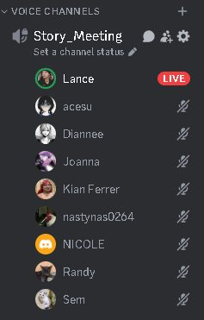

Screenshots by Dianne:

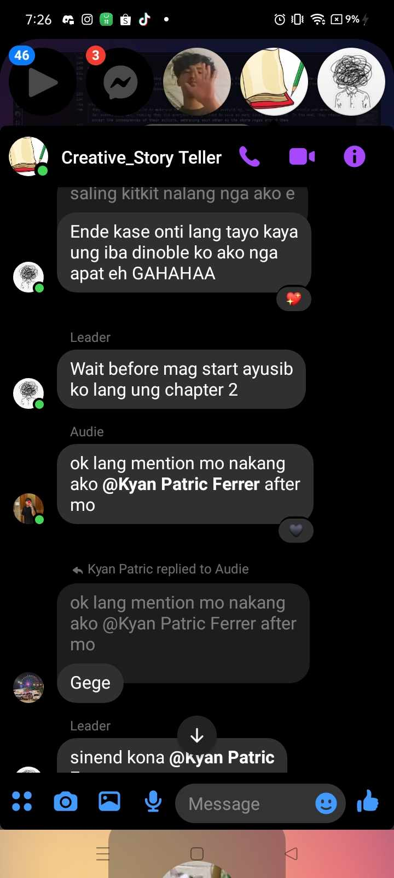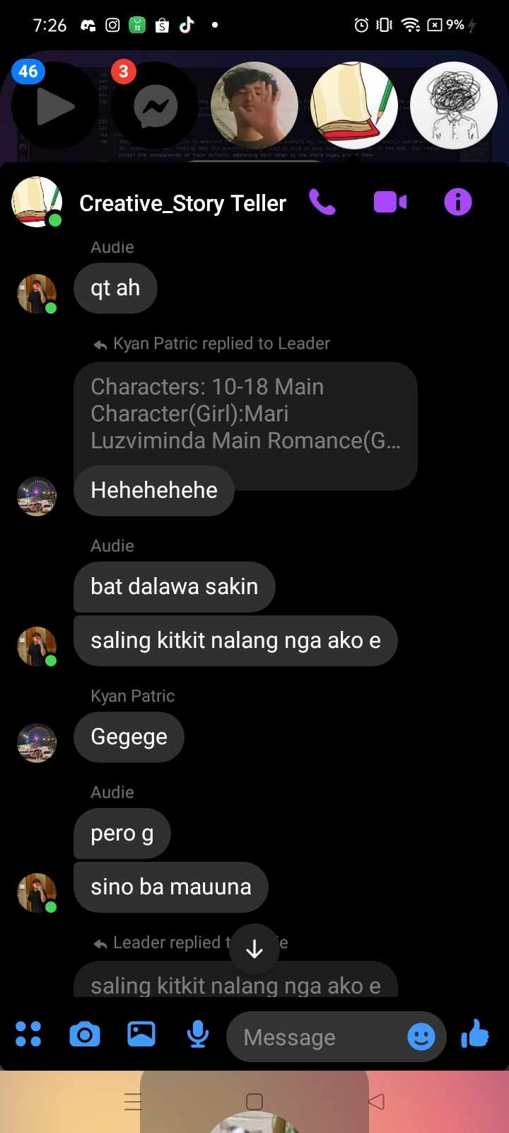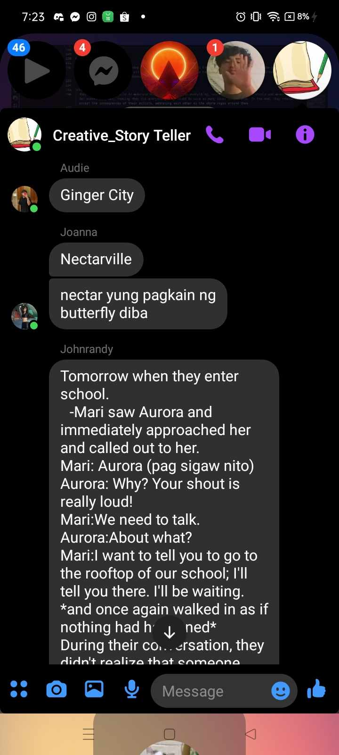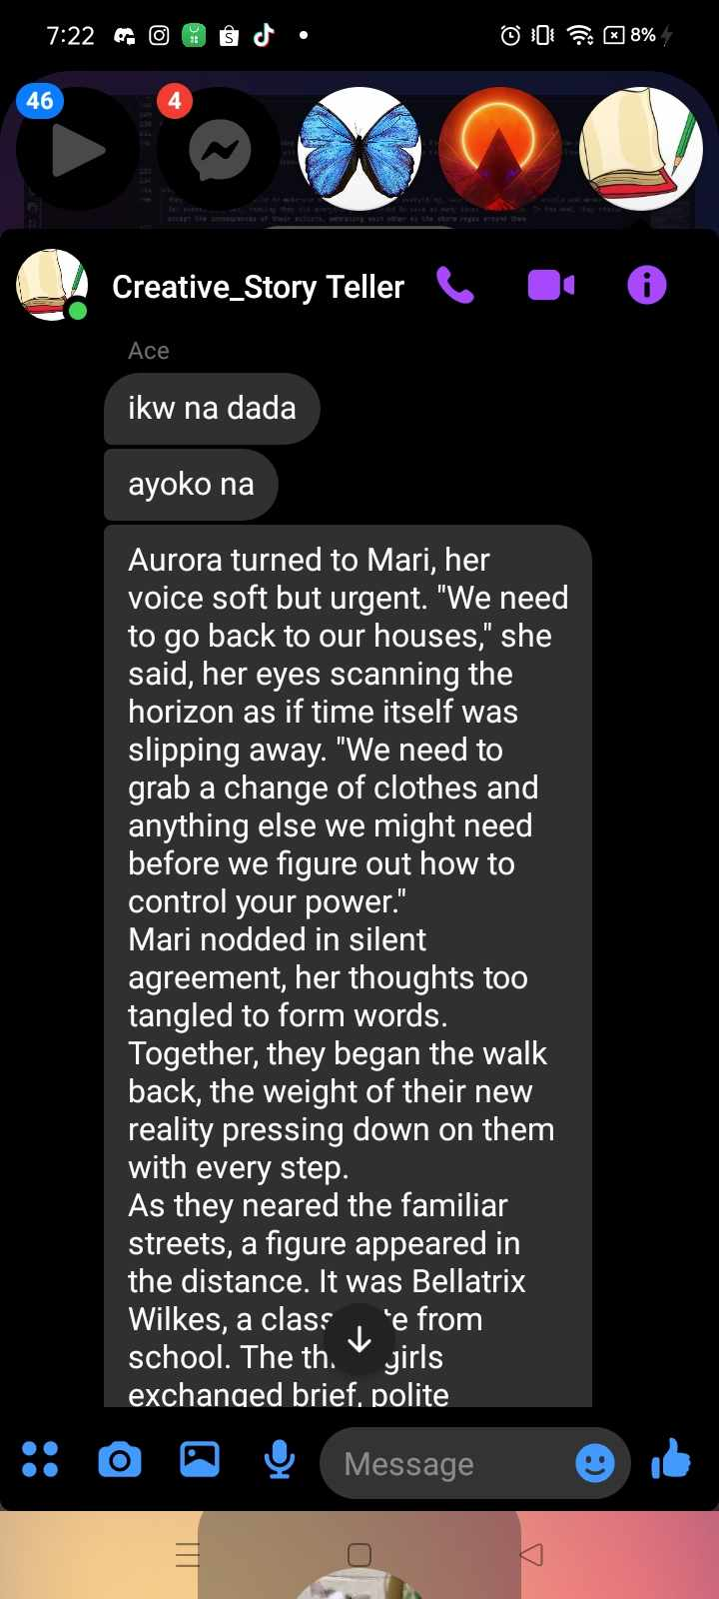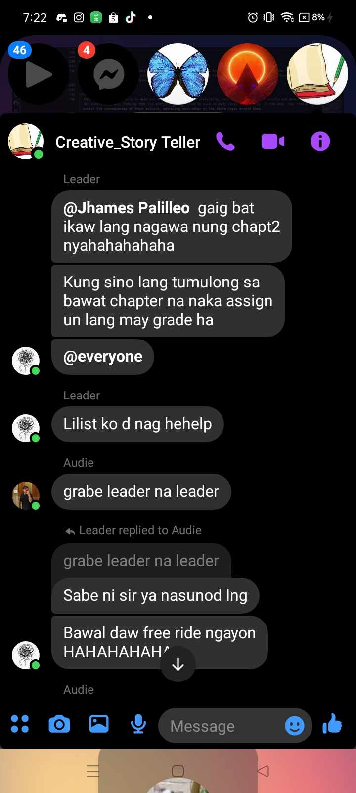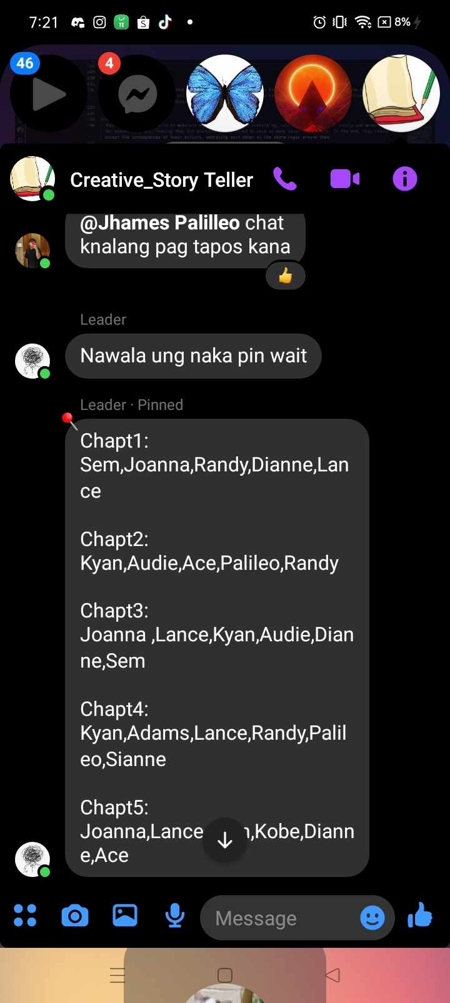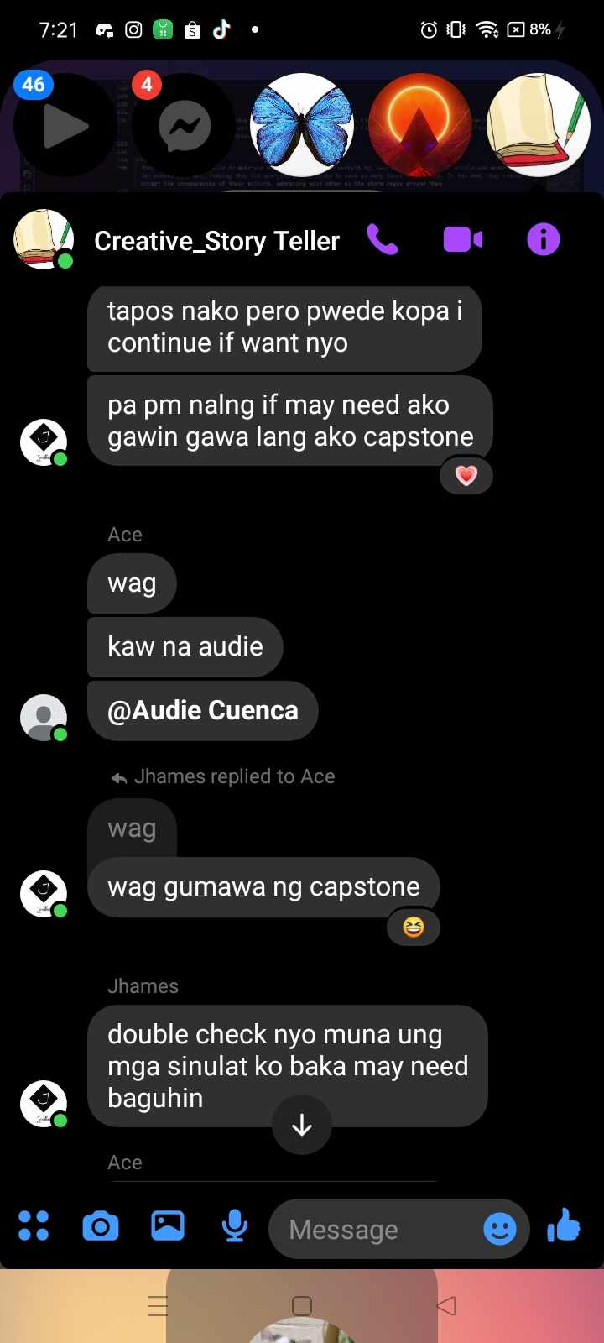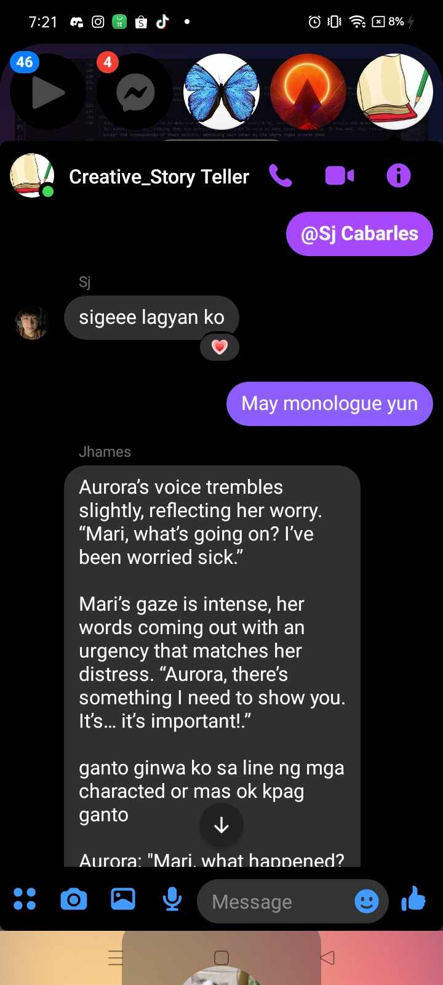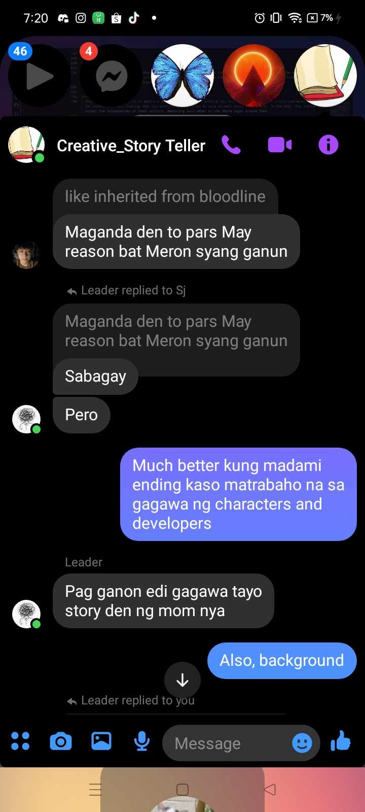

Members who participated in making the characters, stories, and plots:

**Obaña**

Ola

Pagdato

Cuenca  
Palileo  
Capote  
Cabarles  
Orilla  
Ferrer

Members who did not participate:

**Progilla  
Villegas**

Also, sir may nasama daw po si ola sa story role na dapat is nasa audio role pasensya nadaw po, bali I uupdate na den daw po nya sa github now:  
Villazor